Group Project Documentation   
Basic Cross-Platform Application Programming with .NET

*Hospital Management*

**Prepared by Group 9**

***Lâm Minh Phúc SE161448***

***Nguyễn Phan Phước Thịnh SE160111***

***Bùi Phúc Vĩnh SE61430***

**Ho Chi Minh City, 2022**

**Table of Contents**

**Table of Contents ii**

**Revision History ii**

**1.** **Project Introduction 1**

1.1 Product Perspective 1

1.2 User Classes and Characteristics 1

**2.** **Database Design 1**

**3.** **System Architecture 1**

**4.** **Implementation 2**

4.1. Deployment Considerations 2

4.2. Screenshots and explanations 2

**5.** **References 2**

**Revision History**

|  |  |  |  |
| --- | --- | --- | --- |
| **Name** | **Date** | **Reason For Changes** | **Version** |
| *Van Vo* | *01 January 2022* | *Initial draft* | *1.0 draft 1* |
|  |  |  |  |
|  |  |  |  |
|  |  |  |  |

# Project Introduction

## Product Perspective

*<Provide a short description of the project being specified and its purpose. Describes the system that you will implement (this project perspective is not certain to be too detailed. It's just a paragraph so that the reader can understand the system that will be presented).>*

## User Classes and Characteristics

*<You should mention the important issue; other detailed information can be presented in the form of Business rules.>*

*<Identify the various user classes that you anticipate will use this project and describe their pertinent characteristics. Some requirements might pertain only to certain user classes.>*

# Database Design

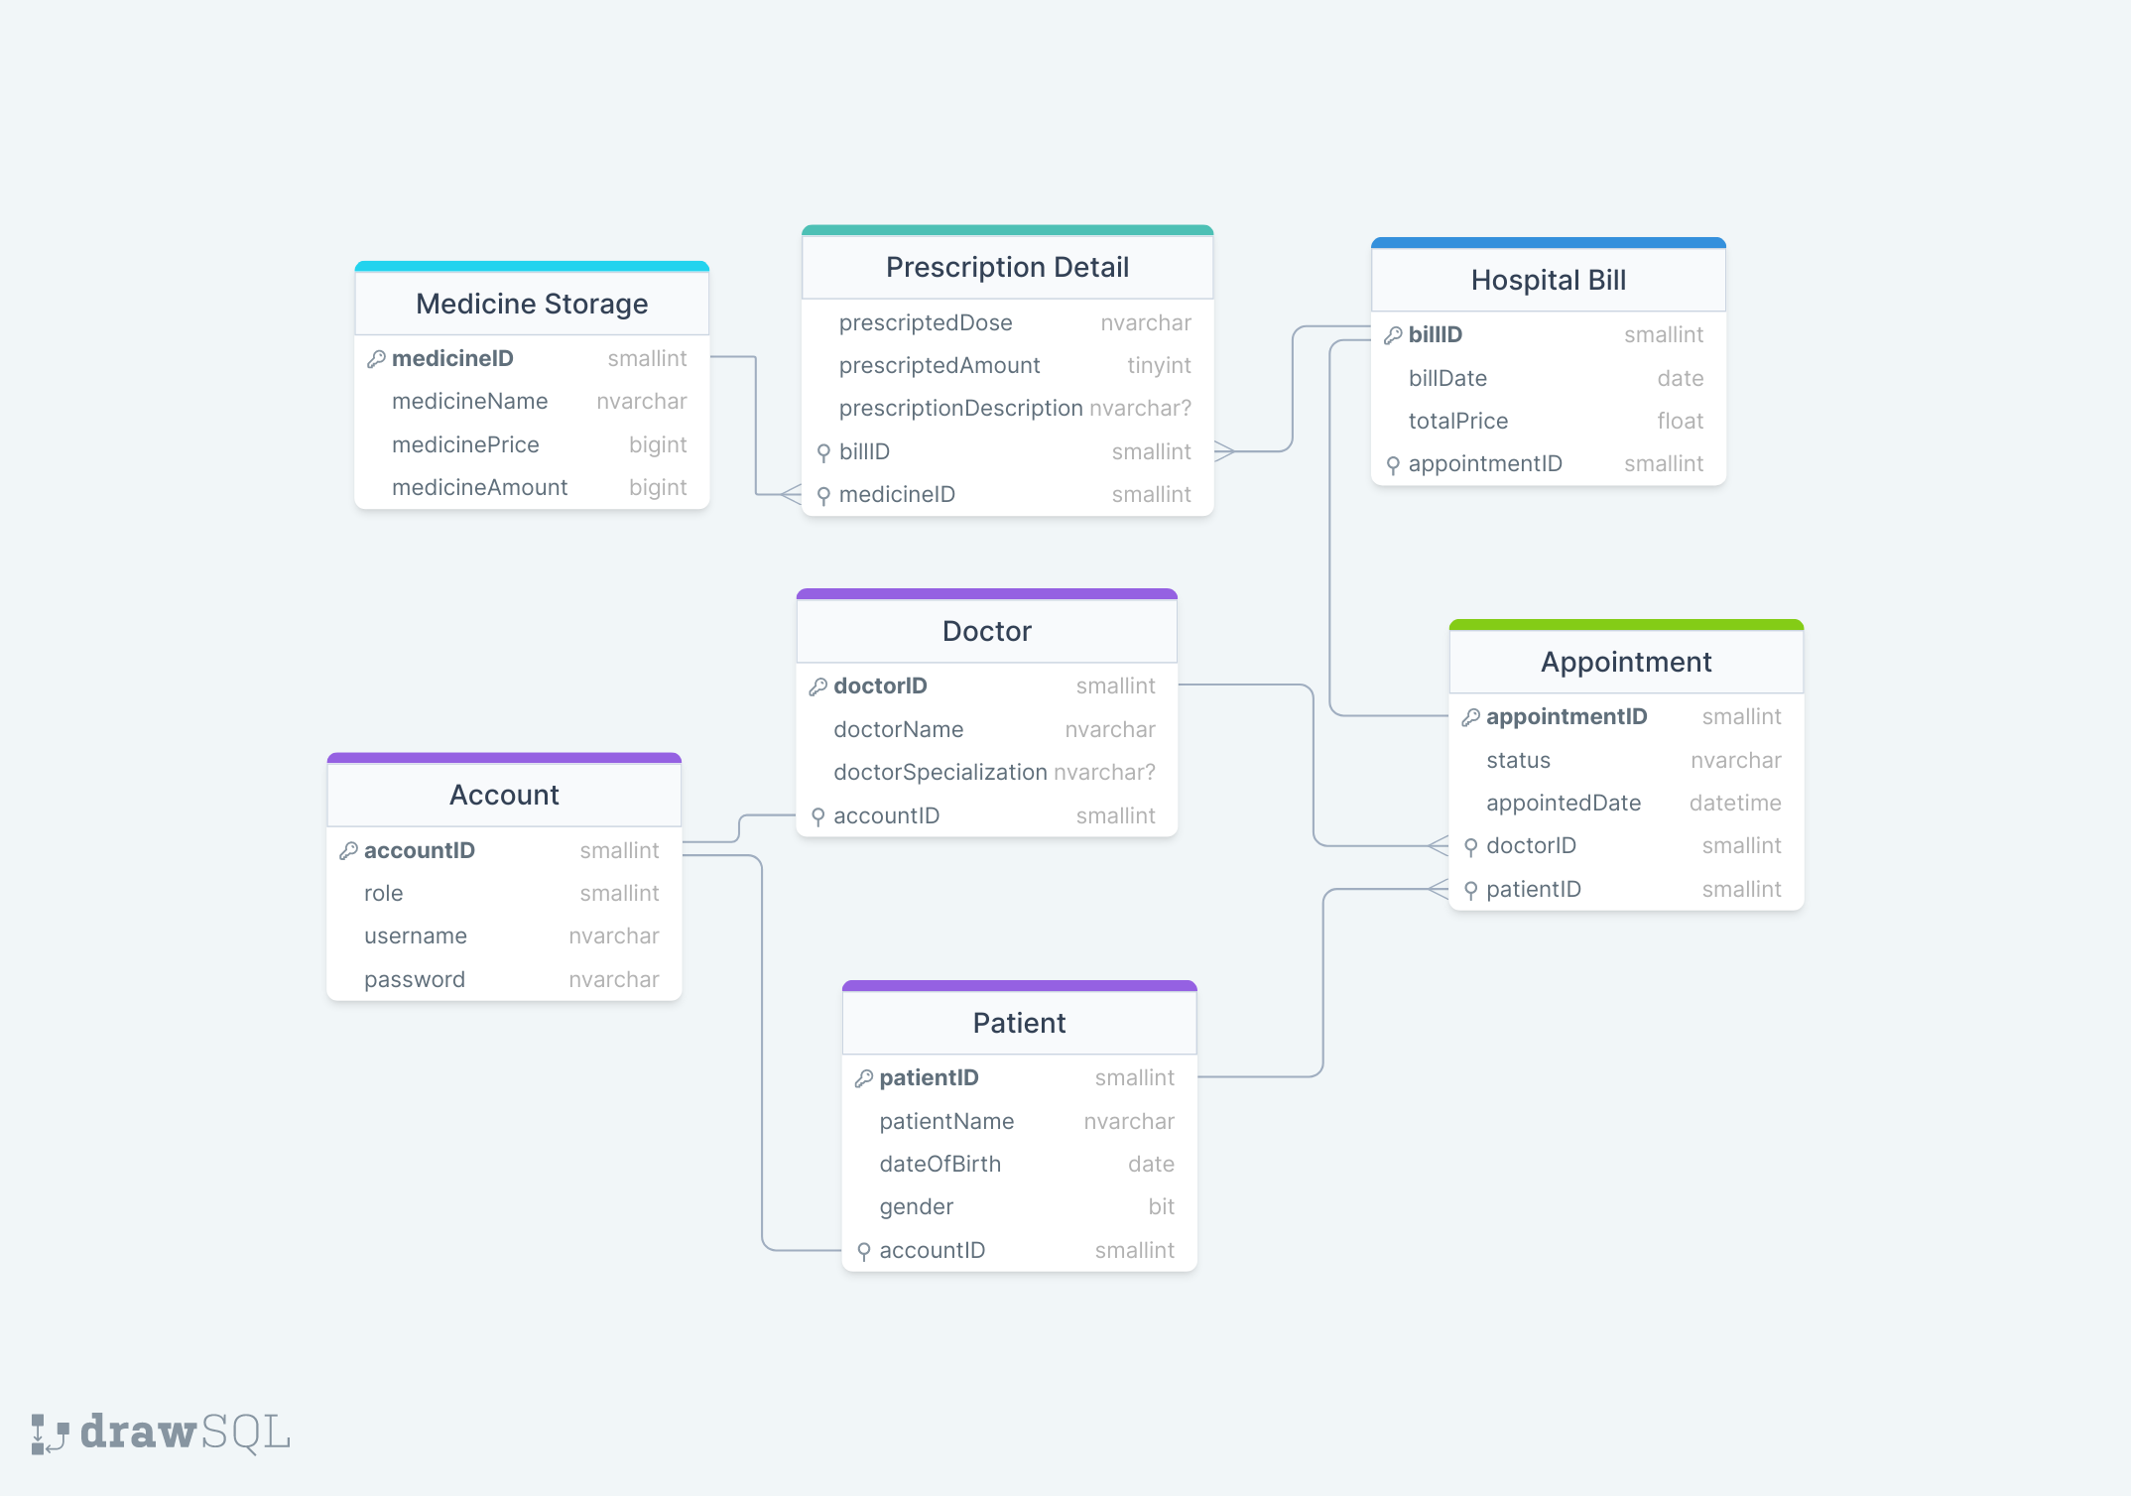

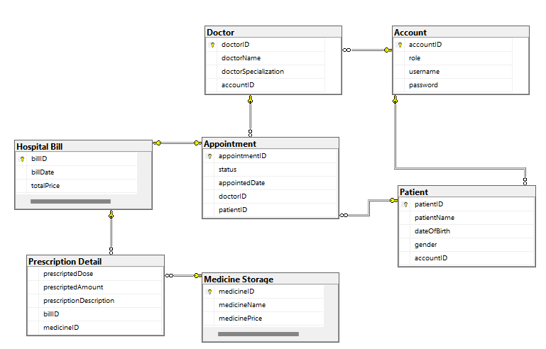

# System Architecture

*<Describe the environment in which the project will operate, including the hardware platform; operating systems and versions; geographical locations of users, servers, and databases; and organizations that host the related databases, servers, and websites.>*

*<A detailed description of how you design the system. You should provide your understanding of your architecture and how your application implemented. The diagrams (eg UML: deployment diagram, class diagrams) should be provided if necessary.>*

*<A detailed description of any new technologies you find out (not in school) to develop applications.>*

# Implementation

## Deployment Considerations

*<Summarize the information and activities that are needed to ensure an effective deployment of the solution into its operating environment.>*

*<Describe the access that users will require to be able to use the system, such as whether the users are distributed over multiple time zones or located close to each other. State when the users in various locations need to access the system. If infrastructure changes are needed to support the software’s need for capacity, network access, data storage, or data migration, describe those changes.>*

*<Record any information that will be needed by people who will be preparing training or modifying business processes in conjunction with deployment of the new solution.>*

## Screenshots and explanations

*<Screen flow>*

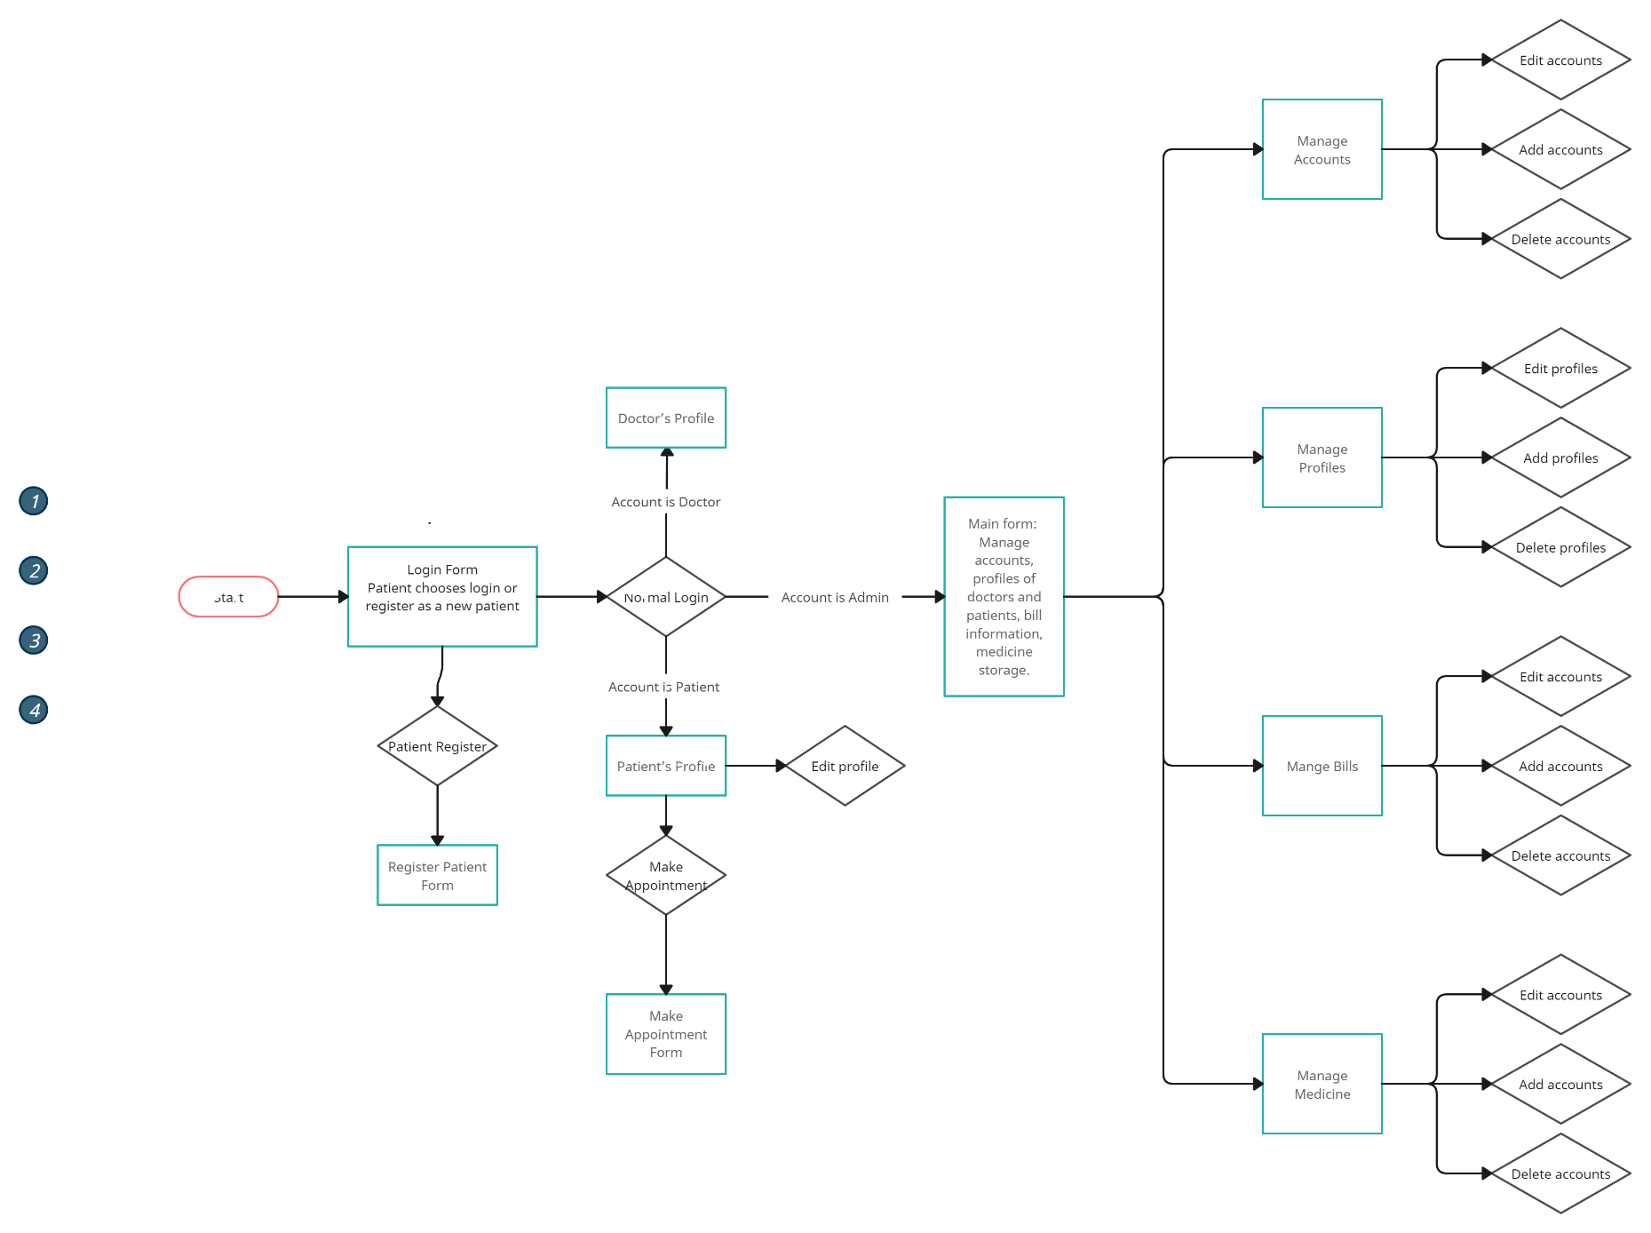

*<The screenshots and explanations>*

# References

1. *Database design made on drawSQL web app: drawsql.app*
2. *Screen flow diagram made on Creately web app : app.creately.com*